**Step-by-Step Guide to Deploying a Spring Boot Application with Docker and Kubernetes** 🚀

**NAME:SRI SURIYA S**

**ROLL NO:22CSL265**

# 1. Initialize and Clone the Repository

Initializes a new Git repository.

Clones the Spring Framework PetClinic project from GitHub.

**Code:**

git init

git clone "https://github.com/AranganathanPrakash/spring-framework-petclinic"

**Screenshot:**

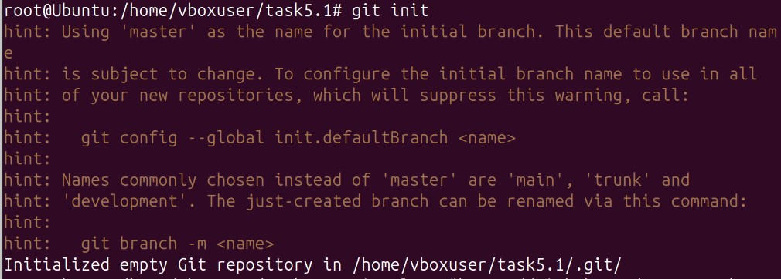

**2. Navigate to the Project Directory** Moves into the cloned repository folder.

**Code:**

cd spring-framework-petclinic

# 3. Update System Packages

Updates the package list to ensure the latest versions are available.

**Code:**

sudo apt update

**Screenshot:**

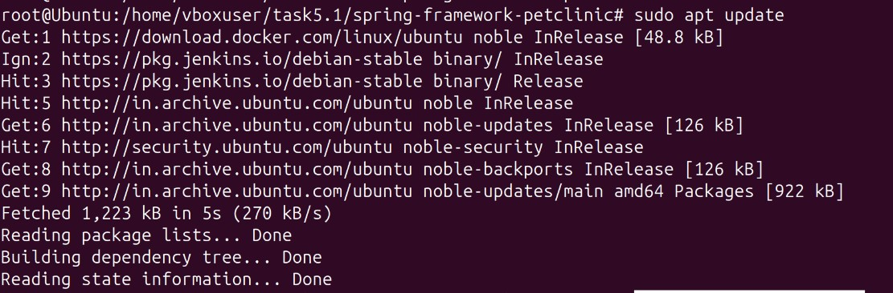

**4. Install Maven**

Installs Apache Maven, required for building the Spring Boot application. **Code:**

sudo apt install maven

**Screenshot:**

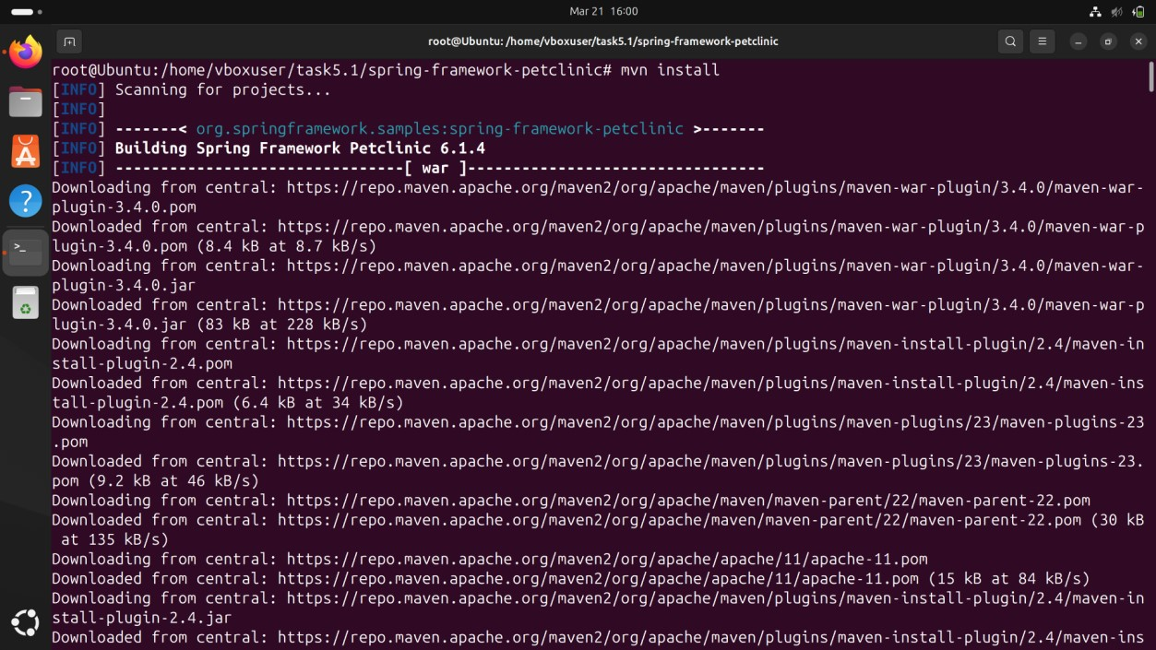

# 5. Verify Maven Installation

Checks if Maven is installed correctly and displays the version.

**Code:**

mvn --version

**ScreenShot:**

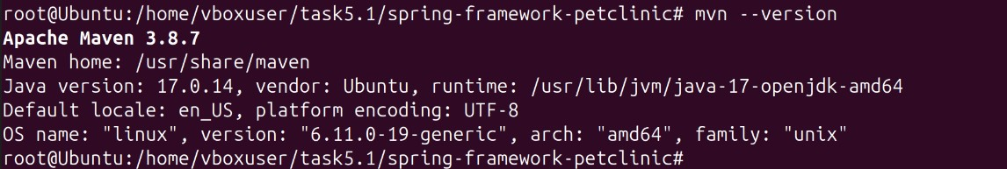

1. **Run Tests (Optional)**

Executes unit tests to ensure the application works correctly.

**Code:**

mvn test

**Screenshot:**

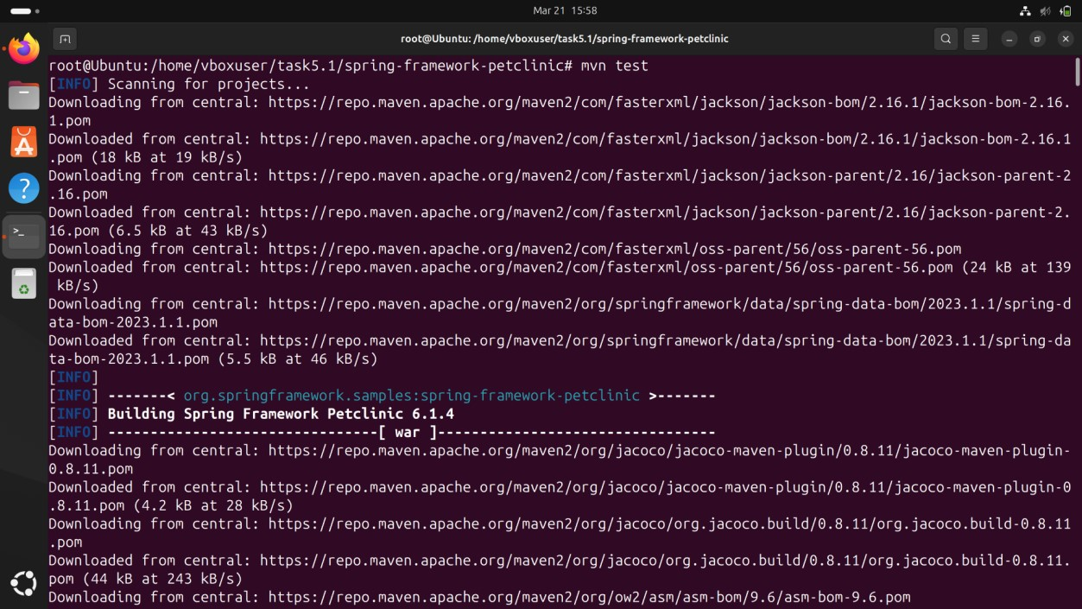

1. **Clean and Build the Application**

**mvn clean: Cleans previous builds.**

**mvn install: Compiles and packages the application. mvn package: Generates the final JAR/WAR file in the target/ directory.**

**Code:**

mvn clean mvn install

mvn package

**Screenshot:**

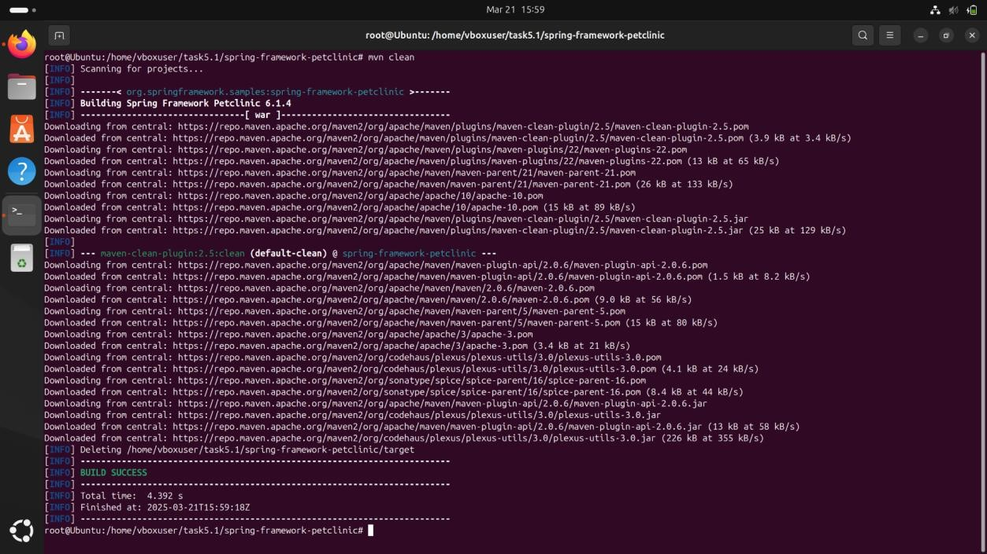



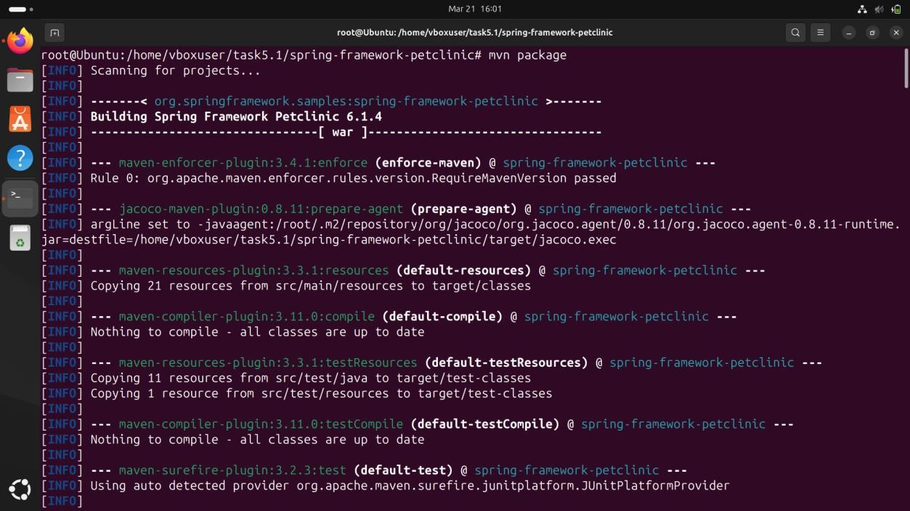

1. **Verify the Built Application**

Navigates to the target folder where the compiled application is stored. **Code:**

cd target ls cd ..

**9. Login to Docker**

Logs into Docker Hub to push container images.

**Code:**

docker login -u vijith22csr239 **Screenshot:**

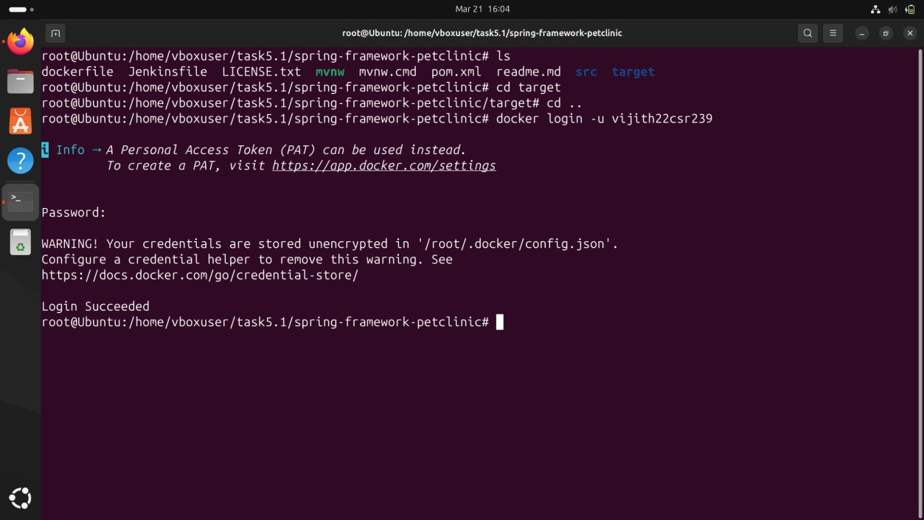

# 10. Build Docker Image

Builds a Docker image with the tag pet from the project directory.

**Code:**

docker build -t pet .

**Screenshot:**

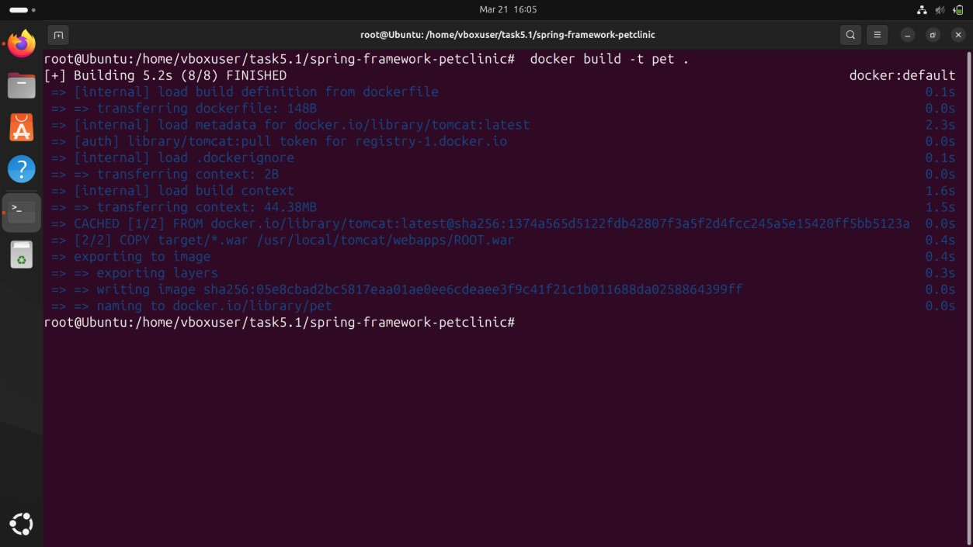

# 11. Tag and Push Image to Docker Hub

Tags the image for Docker Hub.

Pushes the image to your Docker Hub repository.

**Code:**

docker tag pet vijith22csr239/pet:latest

docker push vijith22csr239/pet:latest

**Screenshot:**

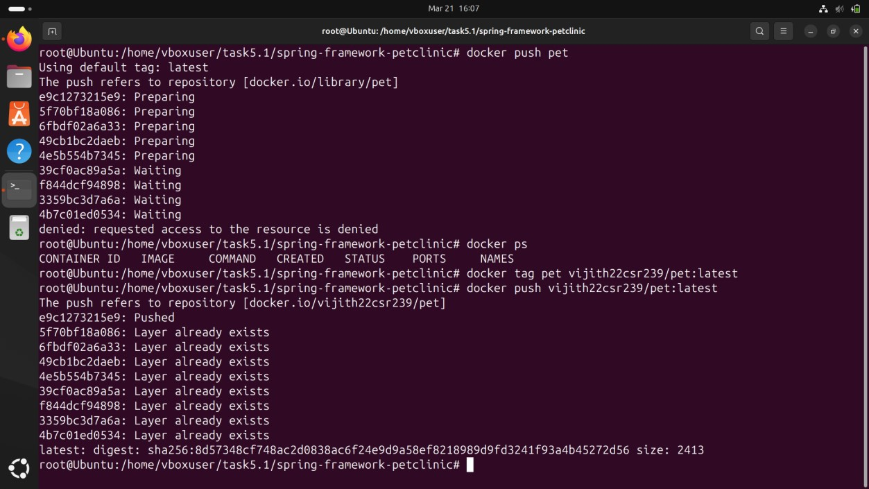

1. **Start Minikube**

Starts a Minikube cluster for Kubernetes.

Checks if Minikube is running properly.

**Code:**

minikube start minikube status

1. **Verify Kubernetes Nodes** Lists available Kubernetes nodes.

**Code:**

kubectl get nodes

**ScreenShot:**

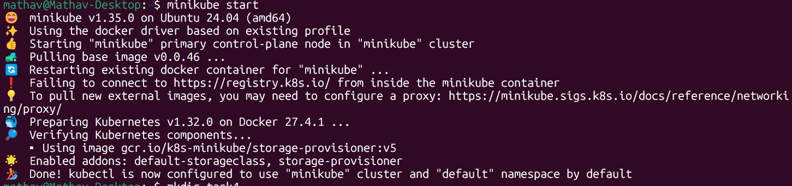

# 14. Deploy the Application on Kubernetes & Expose the Application

Creates a Kubernetes deployment using your Docker image.

Exposes the deployment as a service, making it accessible via Minikube.

Lists all running pods to verify the deployment is successful.

**Code:**

kubectl create deployment pet --image=vijith22csr239/pet --port=8080 kubectl expose deployment pet --port=8080 --type=NodePort kubectl get pods

**Screenshot:**

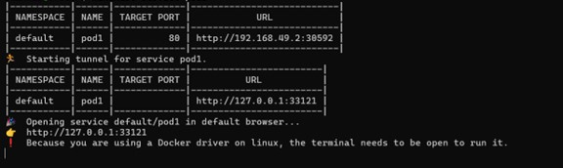

# 16. Access the Application

Opens the application in the browser via Minikube.

**Code:**

minikube service pet

**Screenshot:**

